**LATCHES AND FLIP-FLOPS**

**LAB # 09**



**Fall 2021**

**CSE-202 Digital Logic Design**

**Submitted by: Ebtihaj Abdullah**

**Registration No. : PWCSE1885**

**Class Section: A**

**“On my honor, as student of University of Engineering and Technology, I have neither given nor received unauthorized assistance on this academic work.”**

**Submitted to:**

**Engr. Faiz Ullah**

**DATED: 23 / FEB / 2021**

**Department of Computer Systems Engineering**

**University of Engineering and Technology, Peshawar**

**OBJECTIVES:**

* TO verify state tables of R-S and D flip-flops (with PRESET and CLEAR inputs) using

NAND gates.

**APPARATUS:**

* 7410 IC (3 Input NAND Gate)

**THEORY:**

In case of sequential circuits the effect of all previous inputs on the outputs is represented by a state of the circuit. Thus, the output of the circuit at any time depends upon its current state and the input. These also determine the next state of the circuit. The relationship that exists among the inputs, outputs, present and next states can be specified by either the state table or the state diagram. The state table representation of a sequential circuit consists of three sections labelled present state, next state and output. The present state designates the state of flip-flops before the occurrence of a clock pulse. The next state shows the states of flip-flops after the clock pulse, and the output section lists the value of the output variables during the present state.

**Flip Flop:**

The basic 1-bit digital memory circuit is known as flip-flop. It can store either 0 or 1. Flip-flops are classifieds according to the number of inputs.

**R-S Latch vs R-S Flip-Flop:**

The circuit is similar to R-S latch except enable signal is replaced by clock pulse.

**LOGIC DIAGRAM:**

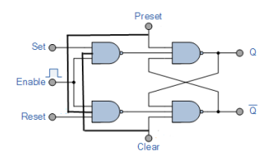

**TRUTH TABLE:**

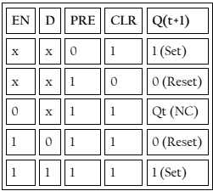

**PROCEDURE:**

* Connections are made as per circuit diagram.
* Verify truth- tables for various combinations of input.

**PRECAUTION:**

* All the ICs should be checked before using the apparatus.
* All LEDs should be checked.
* All connections should be tight.
* Always connect GROUND first and then VCC.
* The circuit should be off before changing the connections.
* After completing the experiment switch off the supply to apparatus.

**OBSERVATIONS:**

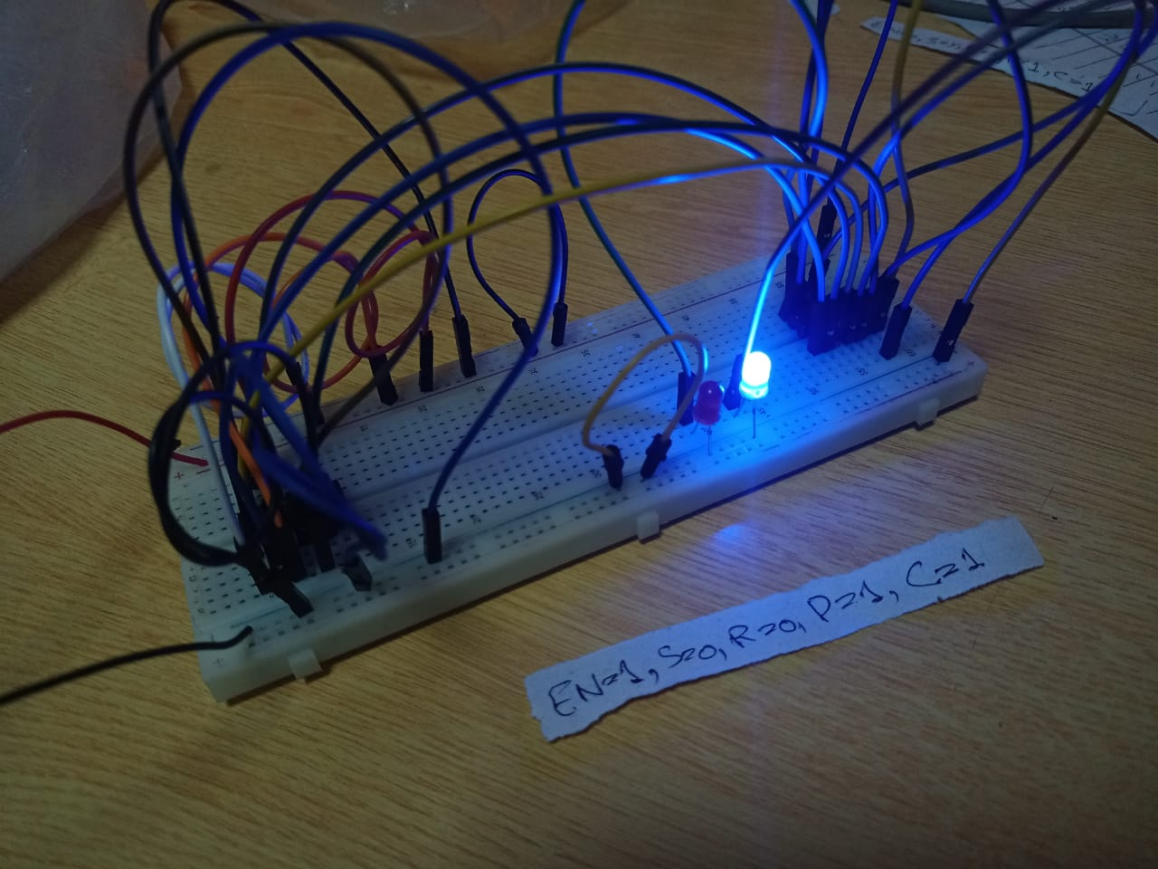

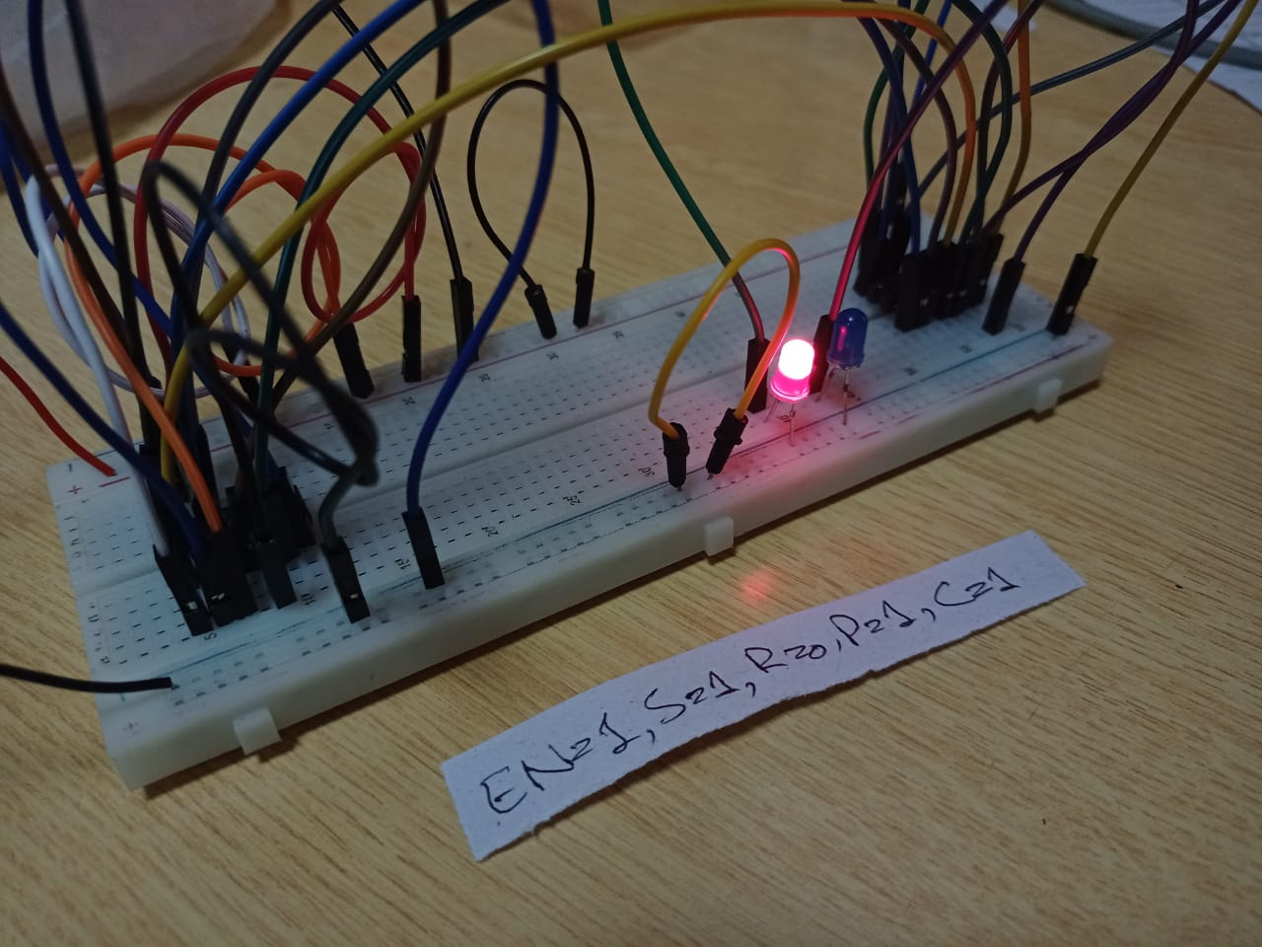

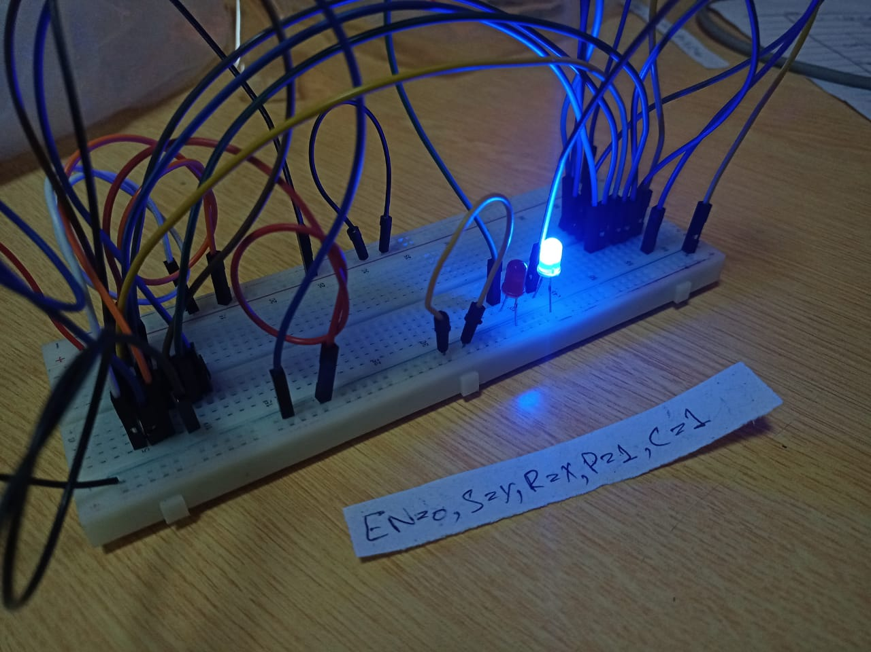

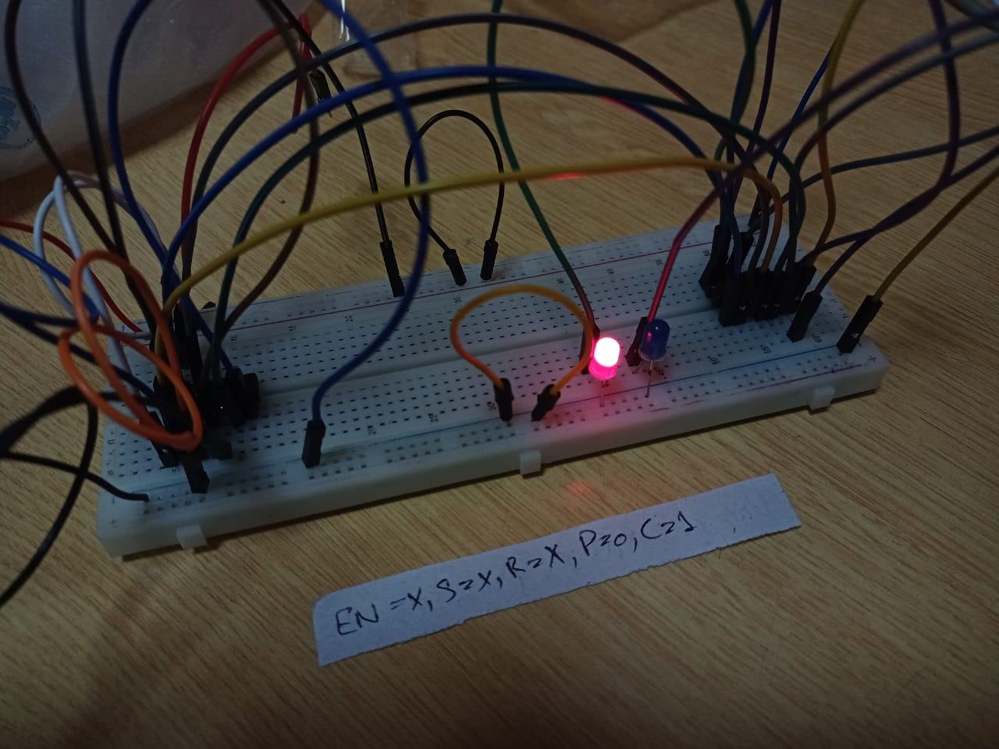

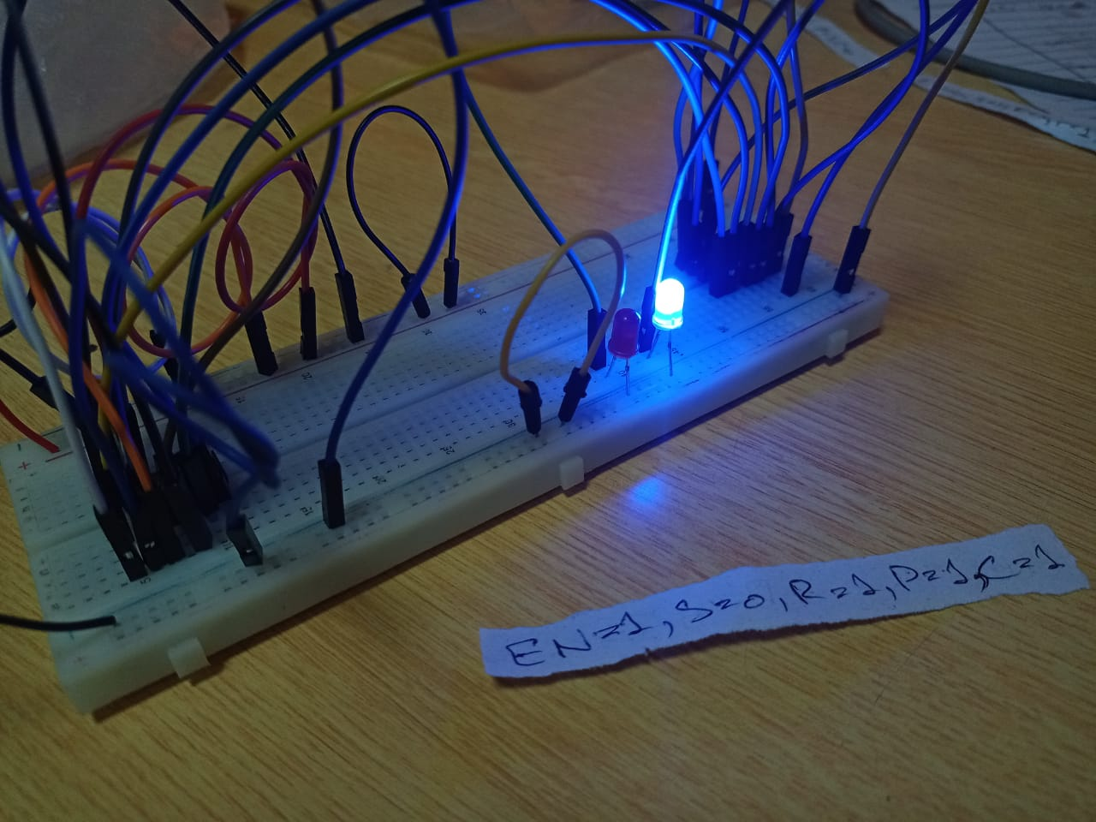

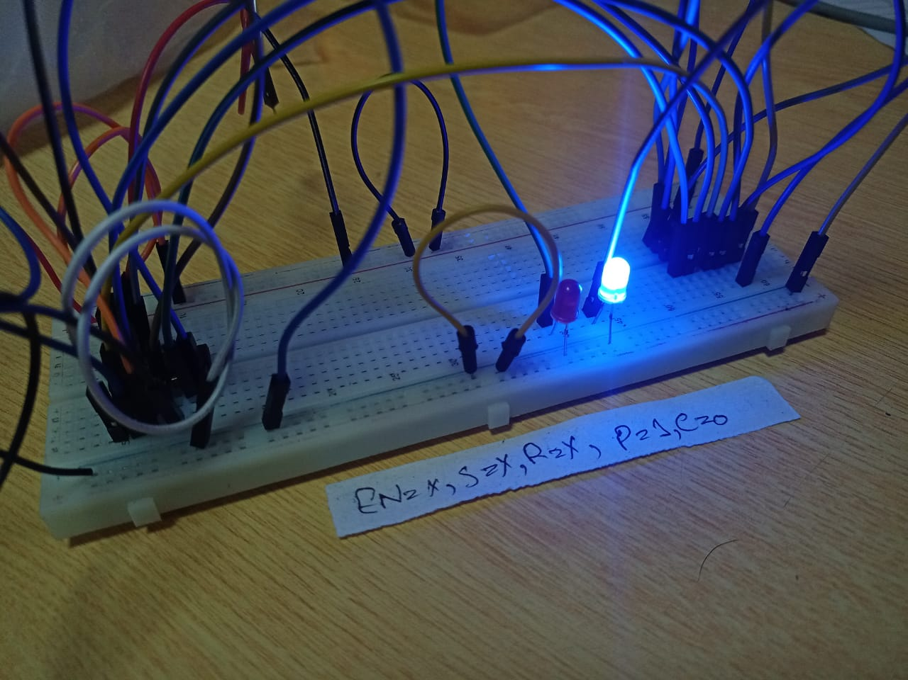

**PRE-LAB QUESTIONS:**

**QUESTION#1:**

Differentiate between combinational and sequential circuits.

**ANSWER:**

Circuit whose output depends upon resent inputs is known as a combinational circuit while a circuit hose output depends upon the present input as well as the past outputs is known as a sequential circuit.

**QUESTION#1:**

What is a Latch?

**ANSWER:**

A sequential circuit (storage element) whose operation depends upon the signal levels.

**QUESTION#1:**

What is a Flip-Flop?

**ANSWER:**

A sequential circuit (storage element) whose operation depends upon clock transitions.